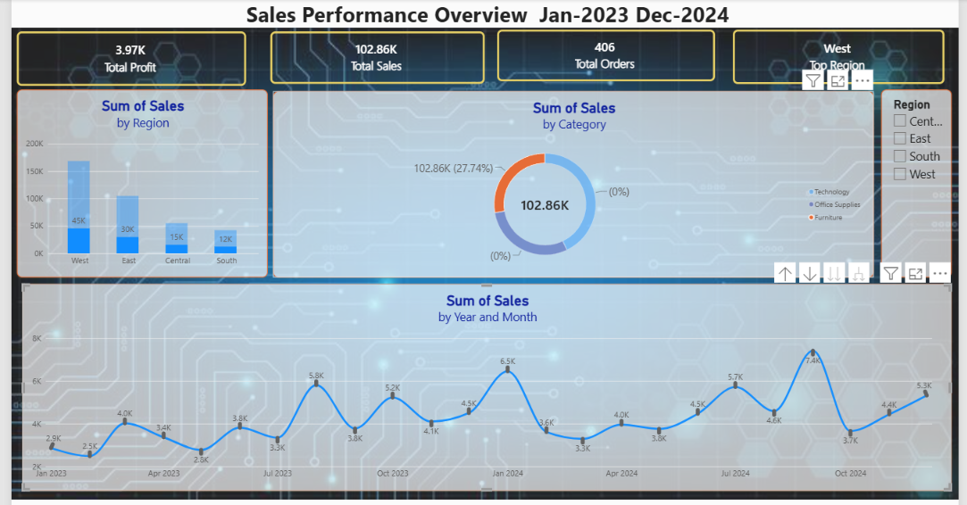
Overview:
This dashboard was built in Power BI using the Superstore_Sales dataset, covering sales transactions from January 2023 to December 2024. It brings together sales, profit, and order data across four regions and three product categories into a single interactive view.
Key insights:
- West region leads sales performance, generating the highest share of revenue among all four regions.
- Sales show a clear seasonal pattern, with noticeable peaks around mid-year and year-end months.
- The Technology consistently contributes a strong share of total sales, making it the category most worth prioritizing.
- region and category slicers let stakeholders filter the view instantly, turning a static report into a tool they can explore on their own.

